

CYBERLOGIQ CONTROLLER
INSTALLATION MANUAL

Revision: 3/18/2024-2.2

Table of Contents
Warranty 3
Introduction 4
Section 1. Safety 5
1.1 Safety Definitions 5
1.2 Safety Considerations 6
1.3 Safety Devices 7
Section 2. Installation 8
2.1 Receiving, Inspection, & Uncrating 8
2.2 Wiring Instructions 8
2.3 Additional Wiring For Basic Configuration 11
2.4 Testing Basic Operation 11
Section 3. Maintenance 12
3.1 Lock Out / Tag Out Procedure 12
3.2 Removing/Installing the Controller from Conveyor 12
Section 4. Troubleshooting 13
4.1 CYBERLOGIQ Controller Error Codes 13
Section 5. Enclosures 14
5.1 Labels 14
5.2 Enclosure Dimensions 15

Warranty
Conveyor Products

- LogistiQ Inc.’s warranty becomes null and void if payment in full is not received for goods and services.
- Unless separately agreed to otherwise, warranty is for 1 year or 4200 hours, whichever comes first, free from defects by faulty material or workmanship, effective from Buyer’s receipt of goods and services.
- LogistiQ Inc. will replace, F.O.B. Sandusky Ohio, or repair equipment proving defective in material and workmanship. Defective parts need to be shipped back to LogistiQ Inc. for inspection at Buyers cost.
- Failure due to abuse, overloading, maintenance neglect, exposure to corrosive or abrasive materials, operation under any degree of dampness, or improper use shall not be subject to this warranty.
- Any modification to equipment or systems without LogistiQ Inc.’s written consent voids this warranty.
- Component parts not of LogistiQ Inc.’s manufacture will be covered by the original manufacturer’s warranty and not LogistiQ Inc.’s. In this case, contact the nearest authorized service representative of the manufacturer.
- Standard warranty does not include labor to remove and/or install defective equipment.
- If LogistiQ Inc.’s service is required for additional assistance, contact our customer service department; labor will be charged at prevailing rate plus travel expenses.
- LogistiQ Inc. shall not be liable for loss of profits, delays or expenses incurred by failure of said parts, whether incidental or consequential.
- LogistiQ Inc. shall not be liable for failure of the goods to comply with federal, state, or local laws.

- See LogistiQ Inc.’s GENERAL TERMS AND CONDITIONS for additional warranty detail.

© LogistiQ Inc. 2022
5225 W Lakeshore Dr. • Port Clinton, Ohio 43452 USA
Phone: (419) 502-2775
LogistiQSales@lewcoinc.com • www.logistiqsolutions.com

Introduction

Thank you for choosing LogistiQ Inc. for your material handling needs. This manual has been prepared by LogistiQ engineers for use in familiarizing personnel with the design, installation, operation, and maintenance of LogistiQ Conveyor Products. Information presented herein should be given careful consideration to assure safe, optimum performance of the equipment. Manual should always be accessible to the operators for quick reference.
This equipment has been designed and manufactured in accordance with applicable National Codes and Standards in effect as of the date of manufacture. It is the responsibility of the end-user to update equipment as necessary to comply with future code changes or revisions.
This manual should be used in conjunction with applicable drawing(s), data sheets, and component manufacturer’s literature attached hereto that clarify specific features, installation, utility connections, operation, etc.
If you have any questions regarding this manual or the use of your LogistiQ Conveyor Products, please contact us by phone at (419) 502-2775 or by email at LogistiQSales@lewcoinc.com.
NOTE: The information in this manual is subject to change without notice and does not represent an obligation on the part of LogistiQ Inc. LogistiQ does not assume any responsibility for any errors that may appear in this manual and under no circumstances will LogistiQ be held liable for technical or editorial omissions made herein, nor for direct, indirect, special, incidental, or consequential damages resulting from the use or defect of this manual.


NOTICE: No installation or operation of this equipment should take place until this manual has been studied and understood by the person(s) responsible.

Copyright © 2022 by LogistiQ Inc.
All rights reserved. Reproduction or copying of this manual by any means, electronic or mechanical, including photocopying, recording, or information storage and retrieval systems is not permitted without the written permission of LogistiQ Inc.

Safety

To reduce the possibility of injury to personnel operating, or in the vicinity of LogistiQ conveying equipment, safety signs are posted at potential hazard points on the equipment. Examine this equipment and become familiar with potential hazard areas. Additionally, instruct all personnel to heed these potential hazard areas.

Safety Definitions
Manual Specific Safety Symbol Definitions
 | Safety Instruction where an electrical hazard is involved.
 | Safety instruction where non-compliance would affect safety.
 | Safety instruction relating to safe operation of the equipment (ATTENTION).
 | Safety instruction where non-compliance could potentially result in a pinch point or a description of a known existing pinch point.
 | Safety instruction where non-compliance could potentially result in a pinch point or a description of a known existing pinch point.
 | Indicates a hazardous situation which, if not avoided, will result in death or serious injury. The signal word "DANGER" is to be limited to the most extreme situations. DANGER [signs] should not be used for property damage hazards unless personal injury risk appropriate to these levels is also involved.
 | Indicates a hazardous situation which, if not avoided, could result in death or serious injury. WARNING signs] should not be used for property damage hazards unless personal injury risk appropriate to this level is also involved.
 | Indicates a hazardous situation which, if not avoided, could result in minor or moderate injury. CAUTION [signs] without a safety alert symbol may be used to alert against unsafe practices that can result in property damage only.
 | Is used to describe preferred to address practices not related to personal injury.
Equipment Specific Safety Signs & Definitions
 | DANGER: Climbing, sitting, walking, or riding on conveyor at any time will cause severe injury or death. Keep Off.
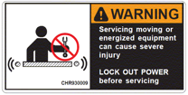 | WARNING: servicing moving, or energized equipment can cause severe injury. LOCK OUT POWER before servicing.
 | WARNING: exposed moving parts can cause severe injury. LOCK OUT POWER before removing guard.
 | WARNING: Moving equipment may cause severe injury. Keep Away.
 | WARNING: Potential arc flash hazard.

Safety Considerations


WARNING
 | - Disconnect and lockout electrical power and all other sources of energy before performing maintenance. Follow proper lockout/ tag out procedures. Know where arc flash is possible and take proper precautions.
 | - Do not have long hair, jewelry, or loose clothing while operating or near the conveyor, as these are potential hazards that could cause entanglement.  - Do not operate equipment without proper guards in place, as bodily injury may result.
 | - Pinch points may exist. Inspect equipment for potential pinch points and use caution.


CAUTION
- This equipment is to be operated by trained personnel only. Operators should be trained under normal and emergency conditions.
- Personnel operating or near the conveyor should be instructed as to the location of stopping devices. Ensure stopping devices are kept free of obstruction.
- Personnel operating or near the conveyor should watch for and be aware of conveying hazards, such as sharp edges, protruding parts, etc.
- Riding on or in the conveyor is strictly prohibited, as serious injury may result.
- Prior to starting conveyor, ensure no work is being performed, all guards are in place, and inspect for foreign objects that could injure personnel or damage equipment.
- Operators should always alert personnel in the area prior to starting the conveyor.
- This equipment may create hazards. The owner is responsible for analyzing the installation of this equipment to make determinations regarding the posting of warning signs to comply with applicable OSHA standards.
- Conveyor should only be used to transport materials or items that it is originally intended and designed to manage.
- Do not load conveyor beyond its designed handling capacity.
- Keep area around the unloading part of the conveyor free from obstructions.
- Check belt tracking to make sure it is running straight on the conveyor.
- After starting conveyor, make sure all areas of the conveyor are operating properly.
- Poor housekeeping practices can cause accidents. Keep conveyor and surrounding area clean from spilled lubricants and other materials.
- Always use extreme caution when using mechanical aids, such as hoists, cables, and other equipment to install or perform maintenance on conveyor. They can cause damage to the conveyor and cause a dangerous condition when the conveyor is turned on.

Safety Devices

- All safety devices, including wiring of electrical safety devices, should be arranged to operate such that a power failure or failure of the device itself will not result in a hazardous condition.
- CYBERLOGIQ controllers should be arranged so that, in case of emergency stop, a manual reset or start at the location where the emergency stop was initiated should be required for the conveyors and associated equipment to resume operation.
- Before restarting a conveyor that has been stopped because of an emergency, an inspection of the conveyor should be made, and the cause of the stoppage determined. The starting device and electrical power must be turned off and locked out/tagged out according to your company’s machine specific procedure before any attempt is made to remove the cause of the stoppage unless operation is necessary to determine the cause or to safely remove the stoppage.
- CYBERLOGIQ server IQ-S-4 and client IQ-CIO-4-4 motor controllers are not to be used in designs requiring safety ratings without the use of a safety rated power interruption circuit. The CYBERLOGIQ controller cards have a dedicated 48VDC power connection that supplies output power to the motors connected to the client IQ-CIO-4-4 and server IQ-S-4 controller cards. This input power is limited to 7.5 AMPS and in the event of a safety stop, this power must be removed by safety rated devices. The application of power must not be allowed until the safety stop condition is cleared and a restart is sounded by an audible device. The CYBERLOGIQ controller cards are not safety rated devices.

Installation

Receiving, Inspection, & Uncrating
- Check the bill of landing with what you have received.
- Examine the equipment for damage during shipping. If damaged:
  - Immediately report bill of lading discrepancies or damage to the vendor and carrier.
  - Obtain a signed damage report from the carrier and send a copy to the vendor.
  - Do not attempt to modify or repair damaged equipment without authorization from LogistiQ Inc.
  - Do not return equipment to the factory without a written return authorization (RMA). Returns without written authorization will not be accepted.
- Look for boxes, accessories, bags, or components such as fasteners, manuals, etc. that may be banded or fastened to the crating material to ensure you do not discard any loose parts that were packaged for loose shipping.
  - Each CYBERLOGIQ controller will ship with the connectors for connecting digital inputs and outputs, motors and input power.

Wiring Instructions
- Mount the controller cards to the conveyor frames in a way that the controller card is in the center of the four motors that it will be connected to. (Figure 1 & 2)
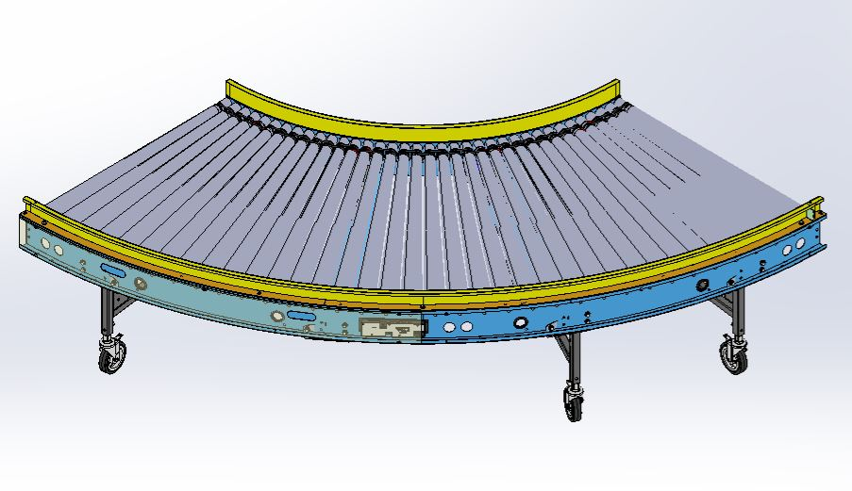
Figure 1

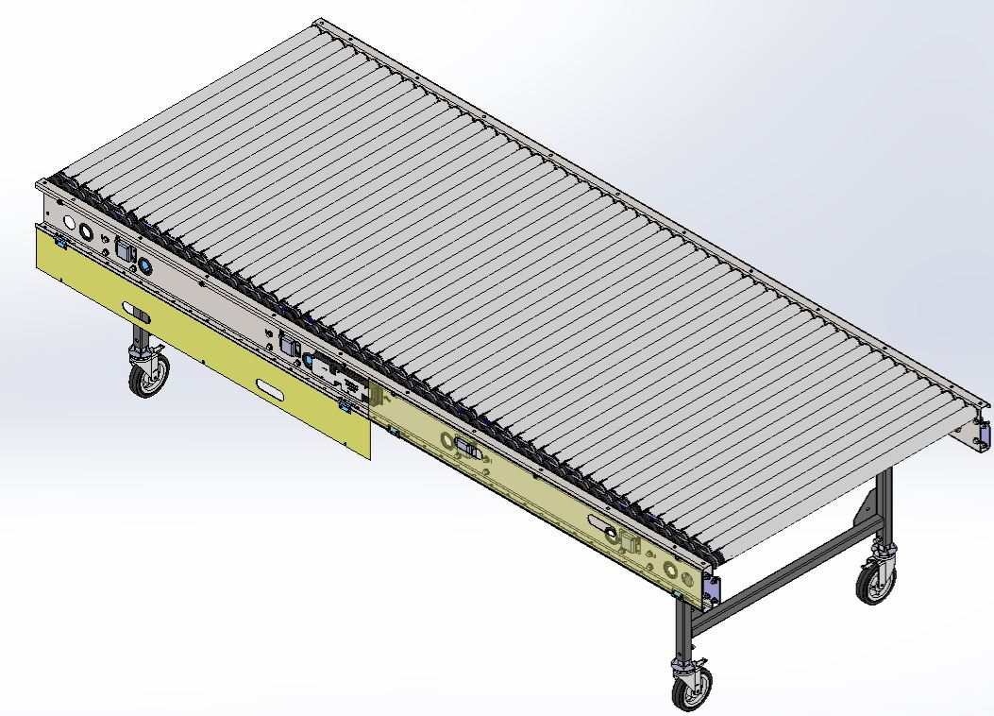
Figure 2
- Connect the switched 48VDC power to the +48VDC motor power and common connections. For systems requiring a safety circuit, this power must be removed during any emergency stop event (Figure 1). This input power should be on a branch circuit capable of delivering 10 Amps.
- Connect the +24VDC logic power to the +24VDC and common connections. This power should be maintained even in the event of an emergency stop of the system. (Figure 1).
- Connect a #14 Grn/Yel wire from the Earth Gnd connection on the controller to the conveyor ground (Figure 1).
- Connect the start and stop pushbuttons, photo-eyes or other digital inputs to the CYBERLOGIQ controller to the terminals labeled sensors 1-4. These connections can supply sensor power for photo-eyes and/or pushbuttons. This applies to server IQ-S-4 and client IQ-CIO-4-4 (Figure 3).
- If digital outputs are required mount the CYBERLOGIQ I/O module IQ-IO-6 IO and connect it to the CYBERLOGIQ controller with the supplied cable assembly (Figure 3).
- Connect the DC motors to the Motor connections labeled MTR1-MTR4. These outputs are limited to 1.5 amps peak for 5 seconds with a minimum armature rating of 48VDC. (Figure 3)

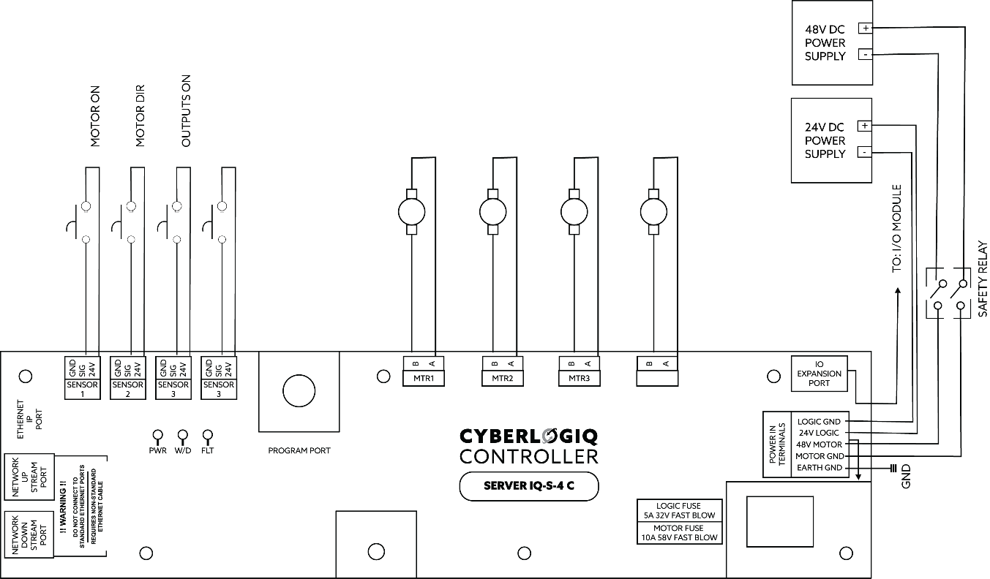
Figure 3

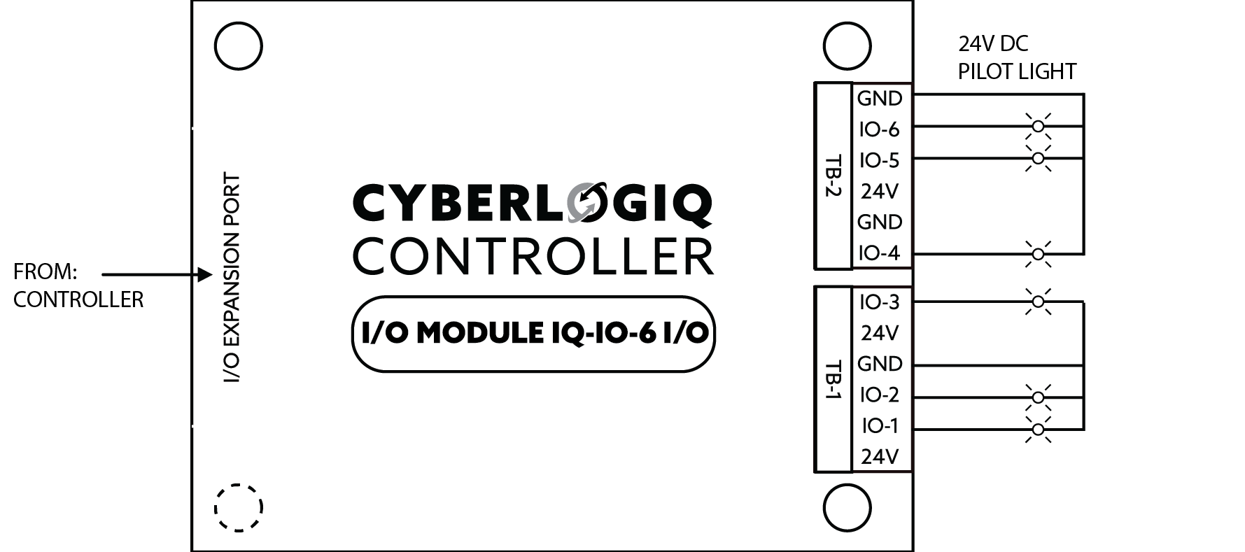
Figure 4

Additional Wiring For Basic Configuration
- The CYBERLOGIQ controller cards have a default program that allows the basic operation of the motor circuits without the use of an external PLC.
- Connect the controllers per section 2.2
- Connect a Normally open switch from the +24 on sensor 1 to the SIG input on the sensor 1 connector MOTOR ON. (Figure 3)
- Connect a Two Position selector switch from the +24 on sensor 2 to the DIG input on the sensor 2 connector MOTOR DIR. (Figure 3)
- Connect a Two Position selector switch from the +24 on sensor 3 to the DIG input on the sensor 3 connector. OUTPUTS ON (Figure 3)
- Connect a Two Position selector switch from the +24 on sensor 3 to the DIG input on the sensor 3 connector. OUTPUTS FLASH (Figure 3)
- Connect the I/O unit to the CYBERLOGIQ controller card with the cable supplied with the I/O card. (Figure 4)
- Connect a 24VDC pilot light from the IO-1 connection point to the GND connection on TB-1 of the I/O module IQ-IO-6 IO. (Figure 4)
- Connect a 24VDC pilot light from the IO-2 connection point to the GND connection on TB-1 of the I/O module IQ-IO-6 IO. (Figure 4)
- Connect a 24VDC pilot light from the IO-3 connection point to the GND connection on TB-1 of the I/O module IQ-IO-6 IO. (Figure 4)
- Connect a 24VDC pilot light from the IO-4 connection point to the GND connection on TB-2 of the I/O module IQ-IO-6 IO. (Figure 4)
- Connect a 24VDC pilot light from the IO-5 connection point to the GND connection on TB-2 of the I/O module IQ-IO-6 IO. (Figure 4)
- Connect a 24VDC pilot light from the IO-6 connection point to the GND connection on TB-2 of the I/O module IQ-IO-6 IO. (Figure 4)
- Connect a 24VDC pilot light from the IO-6 connection point to the GND connection on TB-2 of the I/O module IQ-IO-6 IO. (Figure 4)

Testing Basic Operation
- Closing MOTOR ON switch will supply maximum power to the four motor outputs in the +Polarity.
- Closing the MOTOR DIR will supply maximum power to the four motor outputs in the -Polarity.
- Closing OUTPUTS ON switch will supply 24VDC to the six digital outputs illuminating the pilot lights.
- Closing OUTPUTS FLASH switch will cause the six digital outputs illuminating the pilot lights to flash at the rate of one second on, one second off.

Maintenance

Effective operation and useful life of any equipment is related to the care and service it receives. A pre-determined maintenance schedule, including inspections, and cleaning, should be established for each conveyor section. Establish and maintain “Log Sheets” on each conveyor section to record date and results of inspections, lubrication, and parts replacements. General inspections of all conveyors should be performed at regular intervals depending on use and service conditions.

NOTICE: Do not perform any work on the CYBERLOGIQ controller cards while it is running unless the nature of the maintenance absolutely requires operation of the controller. If the conveyor must be operational to perform maintenance procedures, allow only experienced conveyor maintenance personnel to do the work. Use extreme caution.

Lock Out / Tag Out Procedure

Means to lock out/tag out the conveyors are not provided by LogistiQ. To lock out/tag out the conveyor, refer to integrators conveyor system Manual.

Removing/Installing the Controller from Conveyor

To remove the Controller from the conveyor:
- Lock out/tag out the conveyor following the procedure in the previous section.
- Lock out the 48VDC power source, and shut down the 24VDC logic:
  - Disconnect the 4 motor power connections.
  - Disconnect all sensors/switches plugged into Sensor 1 thru Sensor 4.
  - Disconnect the 48VDC and 24VDC from the power terminals.
  - Disconnect the I/O Module if present.
  - Disconnect the ethernet connections if present.
  - Disconnect the upstream/downstream if used.
  - Remove the controller card.
  - Re-install in reverse order.

Troubleshooting

CYBERLOGIQ Controller Error Codes

The led’s will illuminate on the CYBERLOGIQ controller card if it detects a communication fault, the light could be solid or flashing when operating in stand alone mode.

Table 1: Troubleshooting
TROUBLE | CAUSE | SOLUTION
conveyor does not start or motor stalls/stops | No power | Verify main disconnect switch is on.
 | Motor overloaded | Check sort conveyor loading against design parameters. If red blinking light on motor starter. The motor was overdrawing current
 | Motor needs general maintenance | Check fluid levels to see if motor needs them changed or filled to proper operation levels.
Photo eye not detecting packages | Reflector/photo eye lens dirty | Clean surface with soft, clean dry cloth
 | Photo eye lens not aligned with reflector | Adjust photo eye beam to align with reflective surface
 | Photo eye not connected to power | Reconnect the photo eye to the M12 connector
 | Photo eye defective | Replace photo eye (See spare parts list)
Motor is spinning but belt is not traveling | The pressure roller is not putting enough pressure on the belt face | If springs are malfunctioning, replace springs. (See spare parts list)
Grinding noise | Defective roller | Replace defective roller (See spare parts list)
Grinding noise  Rattling noise | Defective Bearing | Replace defective bearing (See spare parts list)
 | Motor gearbox may need serviced | Contact LogistiQ or Nord for diagnostic assistance. (Motor may need to be sent out for service)
 | Loose hardware | Ensure all hardware is tightened if torque lock paint is misaligned.
Rattling noise | Springs in roller | Replace roller. Springs are not a repairable component

Enclosures

Labels

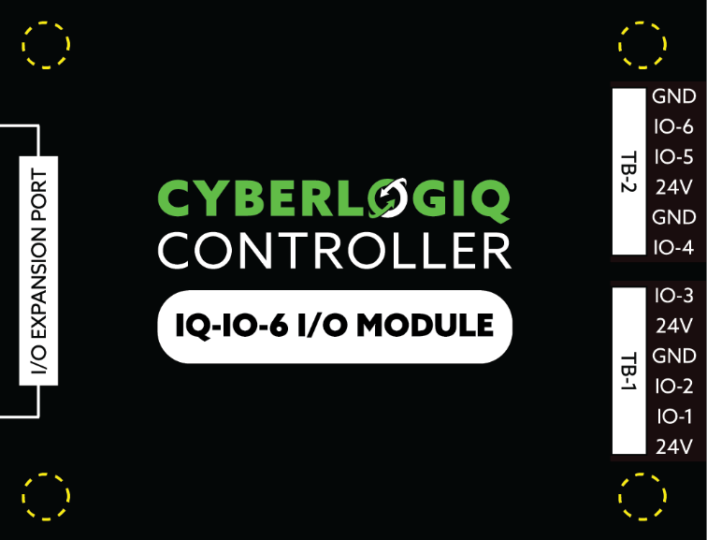
Figure 5

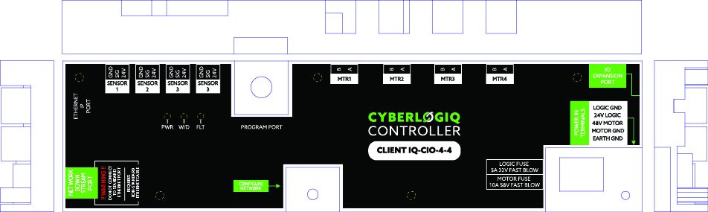
Figure 6

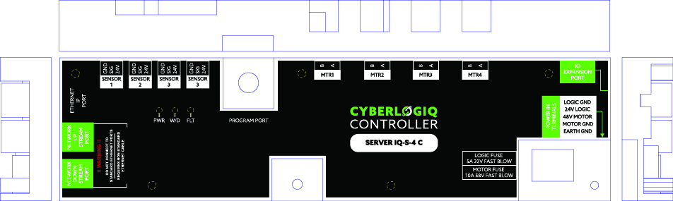
Figure 7

Enclosure Dimensions

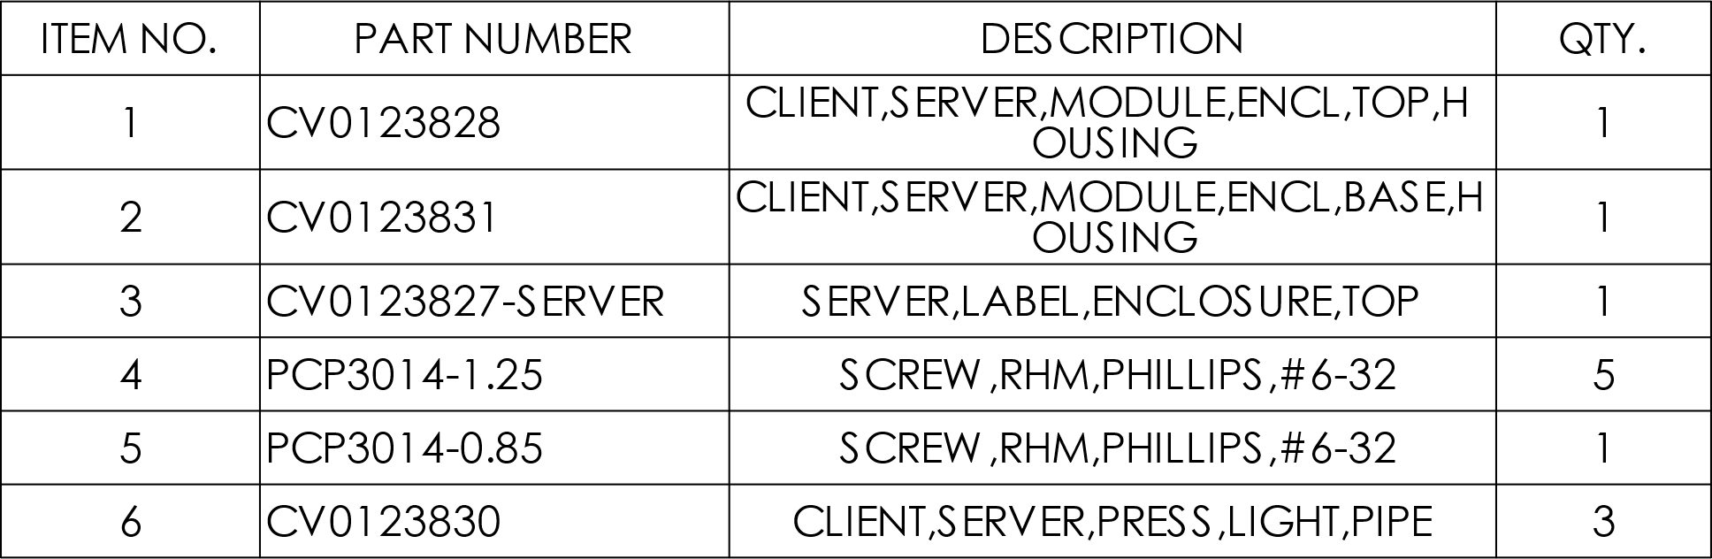

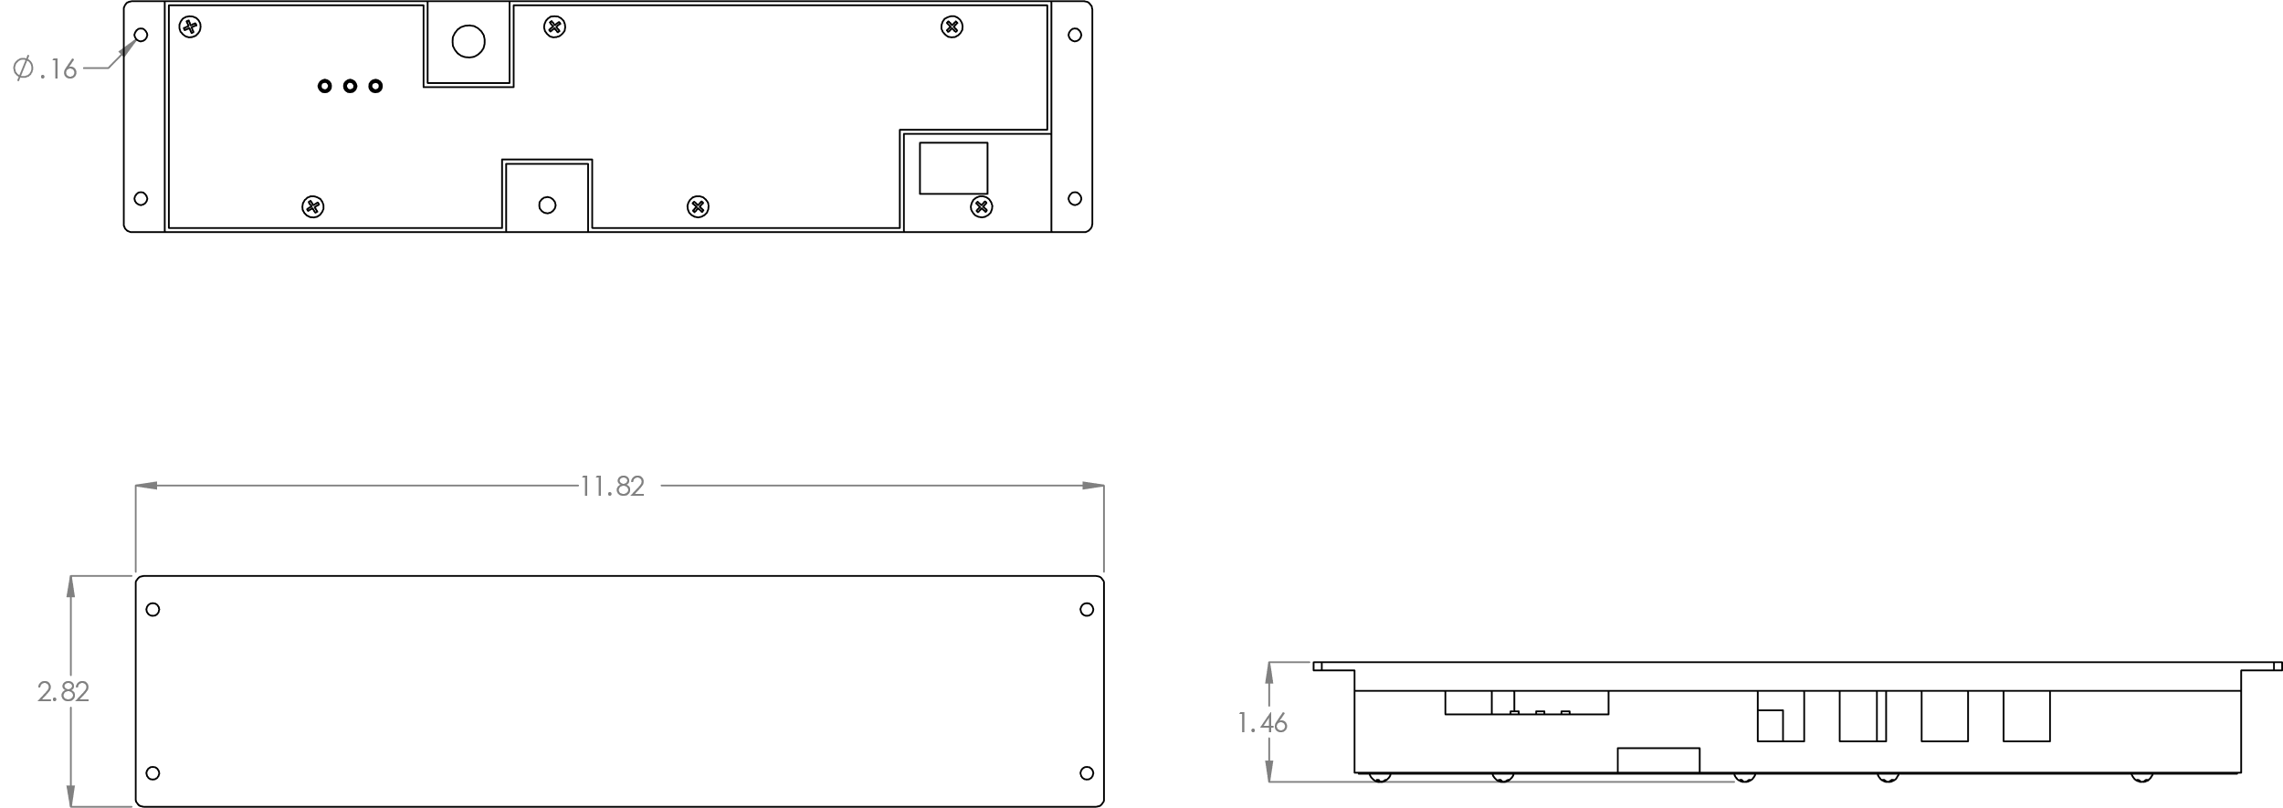
Figure 8

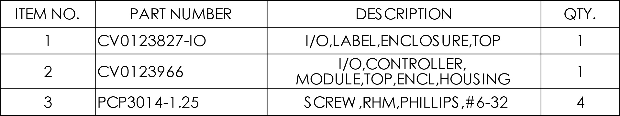

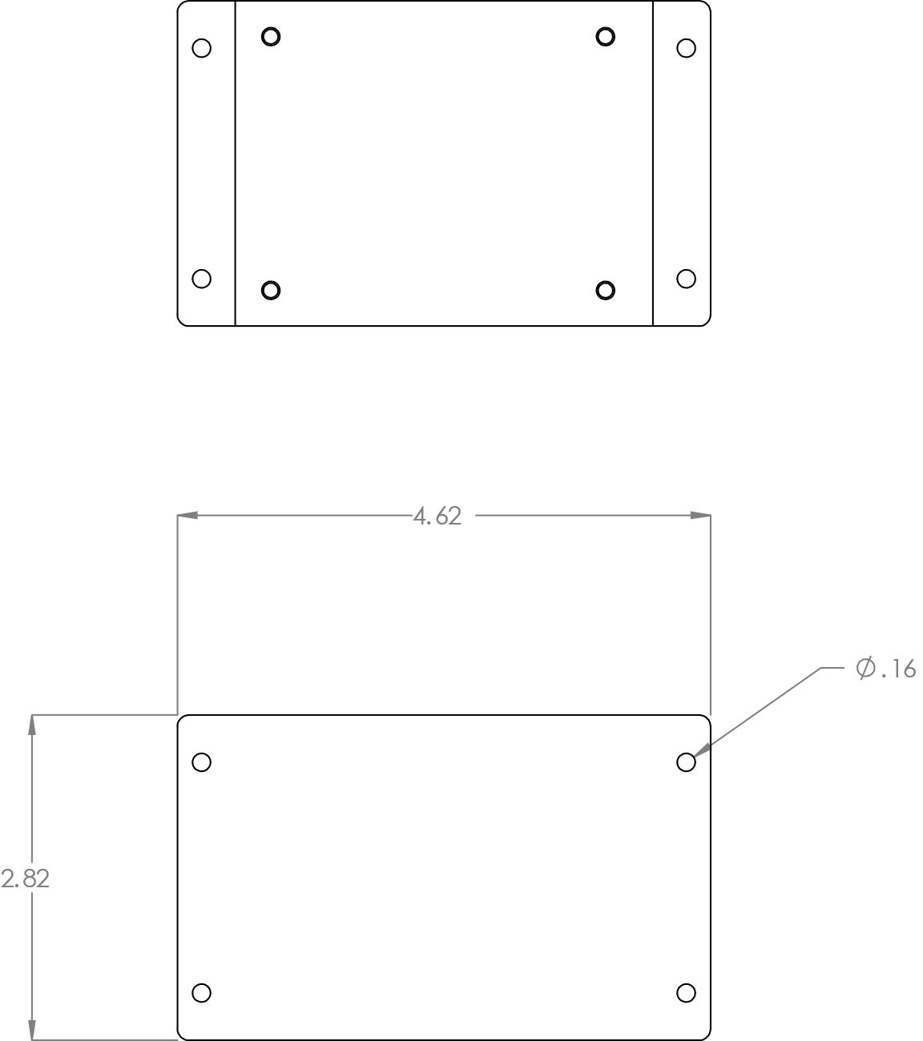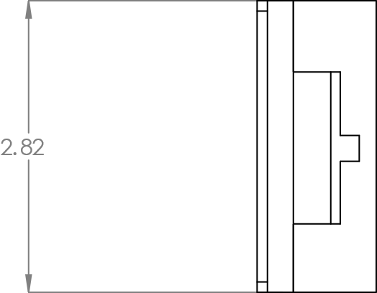
Figure 9

